**Assignment - 4**

**LSTM for Text Classification**

|  |  |
| --- | --- |
| Assignment submission | 6 November 2022 |
| Student Name | Mydheen Beevi B |
| Student Roll Number | 951919CS061 |
| Maximum Marks | 2 Marks |

**1. Download the Dataset**

**2. Import required library**

import pandas as pd import numpy as np import matplotlib.pyplot as plt import seaborn as sns from sklearn.model_selection import train_test_split from sklearn.preprocessing import LabelEncoder from keras.models import Model from keras.layers import LSTM, Activation, Dense, Dropout, Input, Embedding from keras.optimizers import RMSprop from keras.preprocessing.text import Tokenizer from keras.utils import pad_sequences from keras.utils import to_categorical from keras.callbacks import EarlyStopping

%matplotlib inline

**3. Read dataset and do pre-processing** Load the data into Pandas dataframe df = pd.read_csv('/content/spam.csv',delimiter=',',encoding='latin1')

df.head()

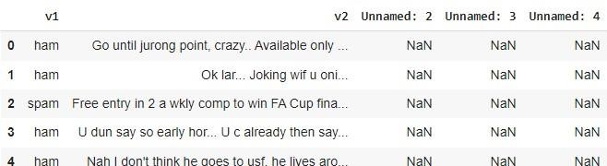

Drop the columns that are not required for the neural network.

df.drop(['Unnamed: 2', 'Unnamed: 3', 'Unnamed: 4'],axis=1,inplace=True) df.info() pH

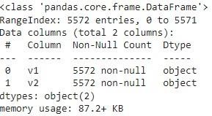

Understand the distribution better.

sns.countplot(df.v1) plt.xlabel('Label')

plt.title('Number of ham and spam messages')

Create input and output vectors. Process the labels.

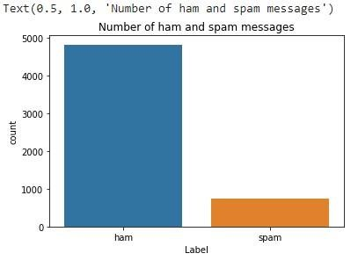

1. = df.v2 Y = df.v1 le = LabelEncoder()
2. = le.fit_transform(Y)

Y = Y.reshape(-1,1)

Split into training and test data.

X_train,X_test,Y_train,Y_test = train_test_split(X,Y,test_size=0.15) Process the data

* Tokenize the data and convert the text to sequences.
* Add padding to ensure that all the sequences have the same shape.
* There are many ways of taking the *max_len* and here an arbitrary length of 150 is chosen.

max_words = 1000 max_len = 150 tok = Tokenizer(num_words=max_words)

tok.fit_on_texts(X_train)

sequences = tok.texts_to_sequences(X_train)

sequences_matrix =pad_sequences(sequences,maxlen=max_len)

**5. Create Model**

**● Add Layers (LSTM, Dense-(Hidden Layers), Output)**

Define the RNN structure. def

RNN():

inputs = Input(name='inputs',shape=[max_len]) layer =

Embedding(max_words,50,input_length=max_len)(inputs) layer =

LSTM(64)(layer) layer = Dense(256,name='FC1')(layer) layer

= Activation('relu')(layer) layer = Dropout(0.5)(layer) layer =

Dense(1,name='out_layer')(layer) layer =

Activation('sigmoid')(layer) model =

Model(inputs=inputs,outputs=layer) return model

Call the function and compile the model.

model = RNN() model.summary() **6. Compile the Model** model.compile(loss='binary_crossentropy',optimizer=RMSprop(),metrics=['accuracy'])

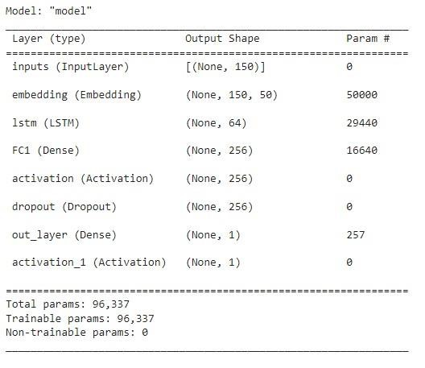

**7. Fit the Model**

model.fit(sequences_matrix,Y_train,batch_size=128,epochs=10, validation_split=0.2,callbacks=[EarlyStopping(monitor='val_loss',min_d

elta=0.0001)])



The model performs well on the validation set and this configuration is chosen as the final model. **8. Save The Model** lstm_model.save('text_model.h5')

**9. Test The Model** test_sequences =

tok.texts_to_sequences(X_test) test_sequences_matrix

=pad_sequences(test_sequences,maxlen=max_len) Evaluate the model on the test set.

accr = model.evaluate(test_sequences_matrix,Y_test)



print('Test set\n Loss: {:0.3f}\n Accuracy: {:0.3f}'.format(accr[0],accr[1]))

